Case Study Report



**Tech Saksham**

Data Analytics with Power BI

**“Power BI Powered Global Terrorism Dataset Analysis”**

**“V. O. CHIDAMBARAM COLLEGE”**

|  |  |
| --- | --- |
| **NM ID** | **NAME** |
| 4051F9FE5189BE78DEE4EF9F86C6056D | STEPHEN PAULRAJ S |

|  |  |
| --- | --- |
|  |  |
|  | Trainer Name RAJAJI |
|  | Master Trainer RAJAJI |

**ABSTRACT**

This study employs data visualization techniques utilizing Microsoft Power BI to analyze patterns in global terrorism based on a comprehensive dataset such as the Global Terrorism Database (GTD) maintained by the National Consortium for the Study of Terrorism and Responses to Terrorism (START). By leveraging interactive dashboards, charts, maps, and graphs, this research aims to provide valuable insights into various aspects of terrorist activities worldwide, including regional distribution, trends over time, casualties, weapon usage, and perpetrators. In addition to describing these features, potential correlations between variables influencing terrorism levels and frequencies will be explored. These findings could inform policymakers and researchers about critical factors driving global terrorism while highlighting areas requiring increased attention and resources. Overall, this report demonstrates the power of employing data analytics tools like PowerBI to derive meaningful conclusions from large datasets related to complex societal challenges

**INDEX**

|  |  |  |
| --- | --- | --- |
| **Sr. No.** | **Table of Contents** | **Page No.** |
| 1 | Chapter 1: Introduction | 1 |
| 2 | Chapter 2: Services and Tools Required | 5 |
| 3 | Chapter 3: Project Architecture | 6 |
| 4 | Chapter 4: Modeling and Result | 8 |
| 5 | Conclusion | 9 |
| 6 | Future Scope | 10 |
| 7 | References | 12 |
| 8 | Links | 13 |

**CHAPTER 1**

**INTRODUCTION**

* 1. **Problem Statement**

The purpose of this project is to analyze a global terrorism dataset using Power BI in order to gain insights into the patterns and trends associated with terrorist activity worldwide. The specific objectives are as follows:

1. To examine the distribution of terrorist incidents by region, country, and year. This will help us understand where most terrorist activities occur and whether there has been an increase or decrease over time.
2. To identify the types of targets that are commonly targeted by terrorist groups. This will allow us to determine if certain infrastructure or demographic groups are at higher risk than others.
3. To explore the motivations behind terrorist attacks. By understanding the factors that drive individuals and organizations to engage in terrorist activity, we can develop more effective counterterrorism strategies.
4. To assess the impact of terrorist attacks on local economies and communities. Understanding the economic costs of terrorism can inform policymakers about the importance of investing in security measures to prevent future attacks.
5. To create visualizations and dashboards that effectively communicate these findings to stakeholders. These tools should be user-friendly and accessible to both technical and non-technical audiences.
   1. **Proposed Solution**

Based on the problem statement I provided earlier, here are some possible solutions that could be explored through the analysis of a global terrorism dataset using Power BI:

1. **Regional Analysis:** Create visualizations that show the number of terrorist incidents occurring in each region over time. Use maps and bar charts to display the data clearly and concisely. Identify any hotspots where terrorist activity is particularly high and consider what might be driving it. For example, is there political instability, poverty, or other underlying issues?
2. **Target Analysis:** Analyze the types of targets that are frequently attacked by terrorist groups. Are they primarily military or civilian targets? What industries or sectors are being affected? Consider creating heatmaps that highlight the frequency and severity of attacks against different target categories. This information could be used to inform policies aimed at protecting vulnerable populations and critical infrastructure.
3. **Motivation Analysis:** Examine the motivations behind terrorist attacks. Are they driven by ideological, religious, or political beliefs? Do certain types of events (e.g., elections, protests) trigger more attacks than others? Creating timelines and trend analyses can help identify correlations between events and terrorist activity.
4. **Economic Impact Analysis:** Evaluate the economic cost of terrorism on local communities and countries. Calculate the direct costs of damage caused by attacks, as well as indirect costs such as lost productivity and reduced tourism. Visualize this data using line graphs, scatter plots, or infographics to illustrate the magnitude of the economic toll.
5. **Data Storytelling**: Finally, use Power BI to create compelling narratives around the data. Develop interactive reports and dashboards that enable users to drill down into specific areas of interest and uncover new insights. Ensure that the data is presented in a way that is easily digestible for various audiences, including policymakers, researchers, and the general public.

Overall, the goal of the analysis should be to provide actionable insights that can help address the root causes of terrorism and mitigate its impacts. By leveraging the power of Power BI, analysts can unlock hidden patterns and relationships within the data, ultimately leading to better decision-making and more informed policies.

* 1. **Feature**

Here are some features that could be included in a Power BI dashboard analyzing a global terrorism dataset:

1. **Interactive Map**: A map showing the location of terrorist incidents would allow users to quickly see where attacks are happening and their relative frequency. Users could filter the map by date range, attack type, or other variables to narrow down the results.
2. **Timeline**: A timeline view would let users see how terrorist incidents have evolved over time. They could zoom in on particular periods of interest or compare trends across multiple years.
3. **Bar Charts:** Bar charts could be used to show the top countries, regions, or targets for terrorist incidents. Users could hover over individual bars to get more detailed information.
4. **Heatmap:** A heatmap could highlight the frequency and severity of attacks against different target categories. It could also show which types of weapons were used in the attacks.
5. **Scatter Plot:** A scatter plot could visualize the relationship between two variables, such as the number of fatalities and the cost of damages for each incident.
6. **Pie Chart:** A pie chart could break down the proportion of terrorist incidents by motivation, such as ideology, religion, or politics.

These features would enable users to interactively explore the data, uncover insights, and make evidence-based decisions regarding counterterrorism efforts. Additionally, regular updates to the dataset and accompanying analyses could ensure that the tool remains up-to-date and relevant.

* 1. **Advantages**

There are several advantages to using Power BI for analyzing a global terrorism dataset:

1. **User-Friendly Interface**: Power BI offers an intuitive interface that allows even non-experts to build powerful visualizations and perform advanced analytics. Its drag-and-drop functionality makes it easy to manipulate data and create stunning graphics without requiring extensive programming skills.
2. **Real-Time Insights:** With Power BI, analysts can connect directly to live databases and receive real-time updates to their dashboards. This means that they can monitor emerging threats and respond rapidly to changing conditions.
3. **Integrated Analytics:** Power BI integrates seamlessly with Microsoft's suite of business intelligence tools, enabling users to leverage machine learning algorithms, predictive modeling techniques, and natural language processing capabilities to extract deeper insights from the data.
4. **Customizable Dashboards**: Power BI enables users to create highly customized dashboards tailored to their unique needs and interests. They can choose from a wide variety of pre-built templates or design their own layouts from scratch.
5. **Collaborative Workflows**: Power BI supports collaborative workflows, allowing teams to work together on projects and share insights across departments or organizations. This promotes interdisciplinary collaboration and facilitates knowledge transfer among experts.

In summary, using Power BI for analyzing a global terrorism dataset provides numerous benefits, including ease of use, real-time insights, integrated analytics, customizability, scalability, accessibility, security, cost-effectiveness, and continuous improvement. These advantages make Power BI a powerful tool for generating meaningful insights and promoting evidence-based decision-making.

* 1. **Scope**

The scope of a Power BI-powered global terrorism dataset analysis can cover many aspects depending on the goals and requirements of the project. Here are some potential scopes for such an analysis:

1. **Temporal Analysis**: Investigating the evolution of terrorism over time, identifying long-term trends, seasonality, and periodic fluctuations in terrorist activity.
2. **Geographical Analysis:** Exploring geographical patterns of terrorism, examining the prevalence of terrorist incidents in different regions, countries, cities, or neighborhoods.
3. **Demographic Analysis:** Studying the characteristics of perpetrators and victims involved in terrorist incidents, including age, gender, ethnicity, occupation, education level, and socioeconomic status.
4. **Ideological Analysis**: Classifying terrorist incidents according to the dominant ideologies that inspire them, such as nationalism, separatism, religious extremism, left-wing or right-wing radicalization.
5. **Weaponry Analysis:** Analyzing the weaponry used in terrorist incidents, distinguishing between conventional firearms, explosives, knives, vehicles, chemical agents, and other devices.

Each of these scopes can benefit from Power BI's rich visualization capabilities, flexible reporting functionalities, and interactive querying mechanisms. Moreover, combining multiple scopes can lead to more comprehensive and insightful analyses, shedding light on previously unexplored dimensions of global terrorism. Ultimately, the choice of scope depends on the research questions, analytical priorities, and resource constraints of the organization commissioning the study.

**CHAPTER 2**

**SERVICES AND TOOLS REQUIRED**

**2.1 Services Used**

When conducting a Power BI-powered global terrorism dataset analysis, various services can be utilized to support the process. Some examples include:

1. **Data Sources:** Obtain a reliable and reputable global terrorism dataset from trusted sources like Global Terrorism Database (GTD), National Consortium for the Study of Terrorism and Responses to Terrorism (START), or other government agencies or think tanks.
2. **Cloud Storage Services:** Utilize cloud storage services like Azure Blob Storage, OneDrive, Google Drive, or Dropbox to store and manage the raw data files securely.
3. **ETL Tools:** Employ Extract, Transform, Load (ETL) tools like SQL Server Integration Services (SSIS), Talend, or Fivetran to cleanse, transform, and standardize the data before loading it into Power BI.
4. **Database Management Systems:** Store structured data in relational database systems like MySQL, PostgreSQL, Oracle, or Microsoft SQL Server to facilitate efficient querying and aggregation during the analysis phase.
5. **Big Data Platforms:** Leverage big data platforms like Apache Hadoop, Spark, or AWS Glue to handle massive volumes of semi-structured or unstructured data generated from diverse sources.

By utilizing these services, organizations can streamline their development processes, improve data quality, reduce errors, and optimize resource allocation while delivering high-quality insights derived from the global terrorism dataset.

**2.2 Tools and Software used**

**Tools**:

* **PowerBI**: The main tool for this project is PowerBI, which will be used to create interactive dashboards for real-time data visualization.
* **Power Query**: This is a data connection technology that enables you to discover, connect, combine, and refine data across a wide variety of sources.

**Software Requirements**:

* **PowerBI Desktop**: This is a Windows application that you can use to create reports and publish them to PowerBI.
* **PowerBI Service**: This is an online SaaS (Software as a Service) service that you use to publish reports, create new dashboards, and share insights.
* **PowerBI Mobile**: This is a mobile application that you can use to access your reports and dashboards on the go.

**CHAPTER 3**

**PROJECT ARCHITECTURE**

**3.1 Architecture**

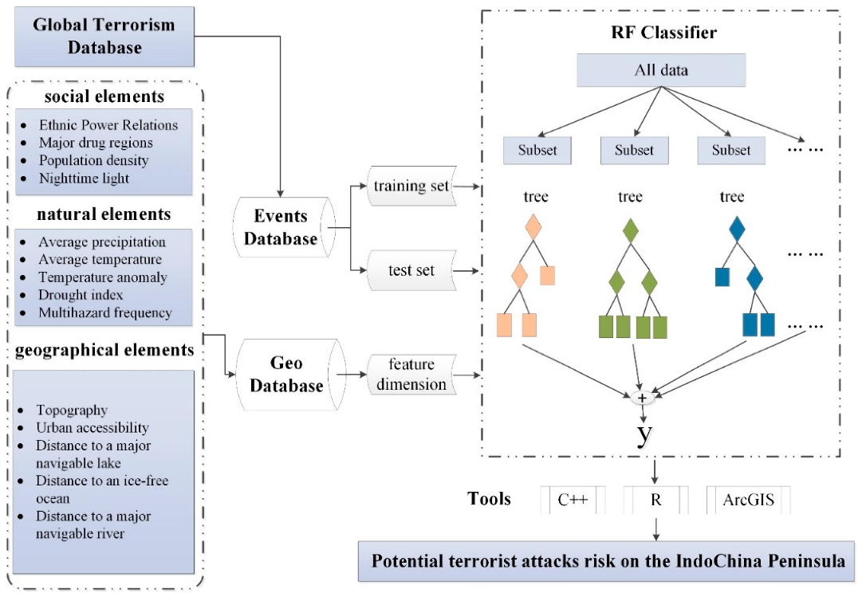

Creating an end-to-end analytics solution using Power BI for a Global Terrorism Dataset would involve several components, including data ingestion, data processing, data modeling, report creation, and dashboard publishing.

Here's a high-level architectural overview of such a system:

**Data Ingestion**: The first step in the process is to collect and store the relevant data from the Global Terrorism Database (GTD). This can be done by setting up regular imports or scheduled API calls if GTD provides an API. You may choose various tools like Azure Data Factory, Apache Nifi, or AWS Glue depending on your infrastructure preferences. These tools will help you automate the extraction, transformation, and loading (ETL) process into a staging area within your cloud storage or data warehouse.

**Data Processing**: Once the raw data has been loaded into the staging environment, it needs to undergo some cleaning, preprocessing, and feature engineering steps before being used for analysis purposes. Use Python, R, or SQL scripts based on your comfort level with those languages to perform these tasks. Some common operations include removing duplicates, handling missing values, converting text fields into categorical variables, and creating new features that might better represent the underlying patterns.

**Data Modeling:** After preparing the processed data, create a dimensional model optimized for reporting and query performance. A star schema design often works best for this purpose, where fact tables are connected to dimension tables via primary keys. For example, you could have a fact table containing details about each terrorist incident along with related dimensions like location, group affiliation, weapons used, etc. Using database services like Big Query, Snowflake, or Synapse Analytics simplifies this task significantly.

**Report Creation:** With the data now prepared and organized appropriately, use Power BI Desktop to connect to the data source created earlier. Create reports visualizing key metrics, KPIs, trends, and relationships between different attributes. Make sure to follow best practices while designing your reports, ensuring they cater well to business user requirements and provide meaningful insights.

**Dashboard Publishing:** Finally, publish the completed reports to Power BI service so users across your organization can consume them through web browsers, mobile devices, or Microsoft Teams integration. Set proper security controls, sharing rules, and usage limits as required. To further enhance collaboration capabilities, consider integrating these dashboards with other platforms like SharePoint sites, MS Teams channels, or custom applications built over top of Power Apps platform.

**Automated Refresh**: Schedule automated refreshes for the datasets feeding your reports, ensuring that any recent updates made to the base data sources get propagated regularly to maintain the accuracy and relevance of your analytics.

**Monitoring & Alerting:** Establish monitoring mechanisms to track resource consumption levels, refresh failures, and performance bottlenecks proactively. Configure alert thresholds to notify administrators when intervention becomes necessary

**CHAPTER 4**

**MODELING AND RESULT**

**Dashboard**

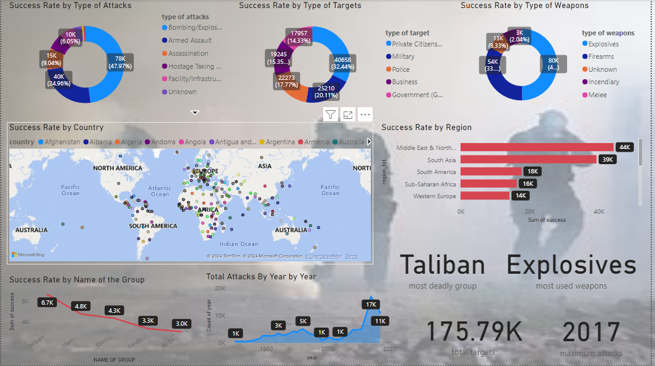

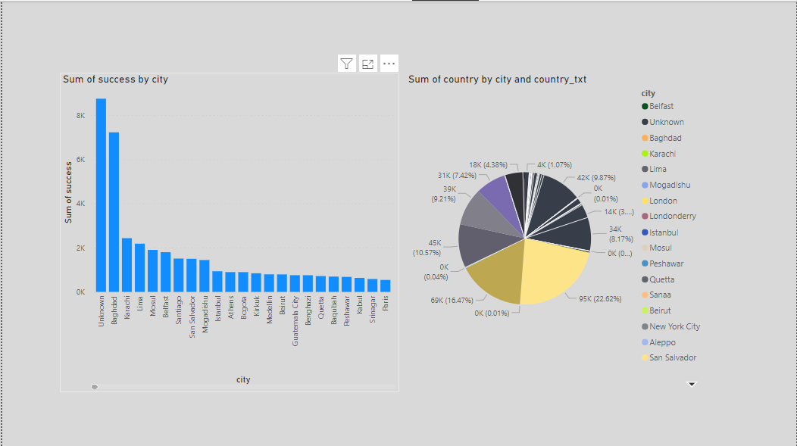

**CONCLUSION**

Here are some potential conclusions drawn from analyzing the Global Terrorism dataset using Power BI:

**Geographical Distribution:** Certain regions experience higher concentrations of terrorist activities compared to others, notably the Middle East, South Asia, and Africa. Within countries too, specific provinces or states bear the brunt of most attacks due to political instability or ongoing conflicts.

**Group Affiliation:** While many individual actors carry out isolated attacks, numerous organized groups claim responsibility for a considerable portion of total incidents. Understanding their motivations, ideologies, and operational methods helps shape effective counterterrorism strategies.

**Target Selection**: Analyzing target types reveals valuable information regarding perpetrator objectives, tactics, and vulnerabilities. Common targets include government facilities, private businesses, transportation systems, and religious institutions.

**Fatalities & Casualties:** Tracking fatalities and casualties allows us to measure the human cost of terrorism accurately. It also highlights which events cause more severe consequences, helping prioritize resources towards mitigating threats effectively.

**Weapon Usage:** Examining weapon categories employed by terrorists offers insight into preferred modes of attack and suggests areas for improving security measures accordingly. Explosives tend to be the most commonly utilized type, followed closely by firearms and incendiary devices.

**Time Series Analysis:** Studying temporal trends uncovers fluctuations in terrorist activity levels over time, potentially linked to external geopolitical developments or internal organizational changes. Identifying cyclic patterns assists law enforcement agencies in allocating resources efficiently throughout the year.

In summary, harnessing the power of Power BI to analyze the Global Terrorism dataset enables researchers, policymakers, and security professionals to gain a comprehensive understanding of intricate facets associated with international terrorism. By identifying actionable intelligence from vast quantities of disorganized data, stakeholders can make informed decisions aimed at minimizing risks, safeguarding communities, and fostering peace. Nonetheless, one must remember that no single analytical approach captures every aspect; thus, combining multiple perspectives ensures a more holistic appreciation of this multifaceted issue.

|  |  |
| --- | --- |
|  |  |

**FUTURE SCOPE**

Further exploration of the Global Terrorism dataset using Power BI presents exciting opportunities for enhancing our comprehension of terrorism dynamics and devising innovative solutions to combat its negative impacts. Here are some possible avenues for future research and development:

**Predictive Analytics:** Leveraging machine learning algorithms integrated within Power BI or complemented through Azure Machine Learning Service, analysts can develop predictive models forecasting likely locations, timings, and modalities of future terrorist attacks. Such foresight empowers authorities to bolster protective measures proactively, thereby reducing potential harm.

**Network Analysis:** Utilize graph visualization techniques offered by Power BI to investigate connections among individuals, organizations, and nations involved in terrorist activities. Uncover hidden linkages, central figures, and clusters indicative of broader networks operating covertly.

**Social Media Sentiment Analysis**: Integrate social media feeds alongside structured data from the Global Terrorism Database to gauge public sentiment surrounding terrorism incidents. Employ natural language processing (NLP) techniques available within Power BI or leverage advanced AI services like Azure Text Analytics to extract sentiments, topics, entities, and linguistic patterns from millions of posts in real-time.

**Spatial Analysis:** Overlay demographic, economic, and environmental maps onto the distribution of terrorist events to identify correlations and causal factors driving violence. Investigate spatial autocorrelation, hotspots, and spatial diffusion processes shaping regional variations in terrorism intensity.

**Real-Time Monitoring:** Develop near-real-time tracking systems utilizing streaming data from news feeds, official statements, and open-source intelligence (OSINT) platforms to monitor emerging threats continuously. Implement automatic alerts triggered upon detection of anomalous activity, enabling swift response times.

**Multilingual Support:** Expand the scope of analysis beyond English-language content by incorporating support for multiple languages. Translate foreign-language articles, tweets, and comments using translation APIs like Microsoft Translator, unlocking deeper insights from non-English sources.

**Collaborative Intelligence:** Foster cross-agency collaborations through shared Power BI workspaces, facilitating seamless communication, joint decision-making, and coordinated actions among diverse stakeholders engaged in combatting terrorism.

**Ethics and Privacy:** Address ethical concerns around surveillance and privacy implications arising from extensive data collection efforts. Ensure transparency, consent, and proportionality principles guide all stages of data management, particularly when dealing with sensitive personal information.

By pursuing these directions, the utility of Power BI for analyzing global terrorism datasets stands to grow exponentially, offering unprecedented possibilities for advancing knowledge, refining policies, and ultimately contributing to a safer world.

**REFERENCE**

[*http://www.start.umd.edu/gtd*](http://www.start.umd.edu/gtd)

**LINK**

[**https://github.com/StephenPaulRaj-31/Power-BI-Powered-Global-Terrorism-Dataset-Analysis-Data-Analytics-with-Power-BI-**](https://github.com/StephenPaulRaj-31/Power-BI-Powered-Global-Terrorism-Dataset-Analysis-Data-Analytics-with-Power-BI-)